Lab 1: Mini UNIX Shell
Test Suite Documentation

This document contains a comprehensive set of test cases for validating the functionality of the Mini UNIX Shell implementation.

1. Simple command
echo hello
Expected:
hello

2. Command with arguments
ls -l
Expected: File listing.
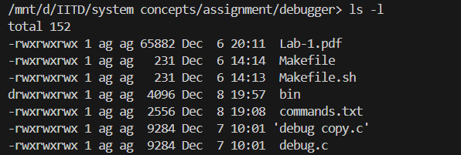

3. Quoted arguments
echo "hello world" '123 456'
Expected:
hello world 123 456

4. Backslash escaping
echo hello\ world
Expected:
hello world

5. Input redirection
Create file:
echo "abcd" > file.txt
Test:
cat < file.txt
Expected:
abcd

6. Output redirection
echo hi > out.txt
cat out.txt
Expected:
hi

7. Append redirection
echo first > log.txt
echo second >> log.txt
cat log.txt
Expected:
first
second
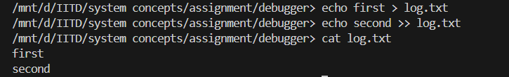

8. Single pipeline
echo hello | wc -c
Expected:
6

9. Multi-stage pipeline
printf "a\nb\nc\n" | grep b | wc -l
Expected:
1

10. Pipeline + redirection
echo "hello world" | tr a-z A-Z > upper.txt
cat upper.txt
Expected:
HELLO WORLD

11. Background command
sleep 2 &
Expected: Immediate prompt return with job ID.

12. Built-in: cd
cd /
pwd
Expected:
/
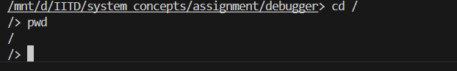

13. Built-in: exit
exit
Expected: Shell exits.

14. Syntax error #1
|
Expected: Syntax error for empty command.

15. Syntax error #2
echo hi & ls
Expected:
syntax error: '&' only allowed at end of line

16. Syntax error #3
echo hi >
Expected: Error: missing filename.

